RVR & JC College of Engineering:

The College

Established in 1985, Rayapati Venkata Ranga Rao & Jagarlamudi Chandramouli College of Engineering, Guntur is the ‘Jewel in the Crown’ of Nagarjuna Education Society, which took upon itself the responsibility of enriching the society through promotion of education, literature and culture. The society was promoted in 1967 by the elite of Guntur, the notable among them being late Sri Jagarlamudi Chandramouli, Dr.K.Sadasiva Rao, Dr.K.Basavapunnaiah, Dr.M.Gopalkrishna, Sri Rayapati Sambasiva Rao, the present Member of Parliament, Lok Sabha, and host of industrial and commercial houses, to mention only a few. As it always happens, the genuine intentions of the promoters of the society received the support of the Almighty. Today eight educational Institutions are functioning under the banner and patronage of Nagarjuna Education Society, with R.V.R. & J.C.College of Engineering, being the flag-ship of them, of course. The Engineering College, since its inception, enjoyed the status of a proud possession of Guntur and truly contributed the objective of offering quality education. True to the expectation of its stakeholders, the college registered a phenomenal growth and today it stands as a premier Institution offering engineering and management education at UG and PG levels.

In 1998, it had become the youngest College to have been accredited by the National Board of Accreditation of the AICTE and as on date, all the seven eligible B.Tech. Degree courses have been accredited, three with A grade and four with B grade which, by far is the best achieved by any private Engineering College in the State. The college has been graded as the second best among the private Engineering Colleges that have been graded by the APSCHE, Hyderabad. The College found a place in ‘INDIA’S TOP-100 ENGINEERING COLLEGES’, according to a nation-wide survey conducted by Cfore for the news weekly ‘OUTLOOK’. It is yet, another hard-earned honour which one cherishes with pride and humility.

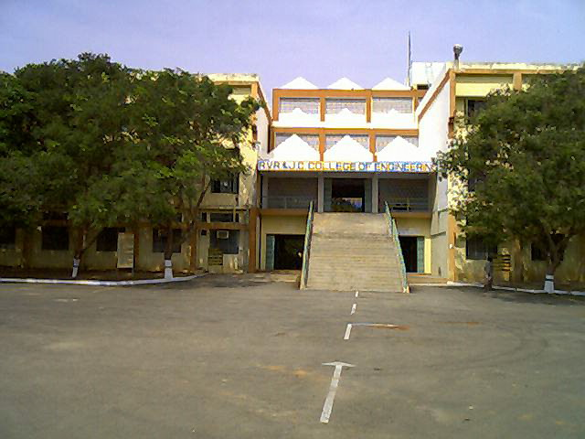

The Department of Management Sciences

The Department presently offers an M.B.A. Degree Programme approved by the AICTE, Government of Andhra Pradesh, with affiliation from Acharya Nagarjuna University. The Faculty uses effective pedagogic tools that include classroom lectures supported by audio visual aids, group discussions, seminars, case studies to make the learning effective and comprehensive. Besides the Department places special emphasis on guest lectures by eminent business executives and senior faculty from the professional institutes of management at the national level.

The Mission of the Department is to prepare young men and women for careers in management in industry, business and government by equipping them with right attitude and value system in life, strong diagnostic and analytical skills and sharp inquisitive minds that are capable of raising searching questions for valid answers.

The MANMEET-2010-11

The Department organizes every year a MANMEET with the following principal objectives:

- To provide a unique opportunity to the third millennium young budding Managers to test their competencies.

- To encourage creative spark, entrepreneurial spirit and innovative competencies in the young future managers for facing up managerial challenges in the ever changing and dynamic E-era.
- To provide a level playing field for the prospective Managers to interact with their peers from sister colleges and Universities in the State.

EVENTS

Business Quiz

- It enables to test the business quotient level of the participants, knowledge of various functions of business and test the pace of their acquaintance with business environment (preliminary & final).

Maximum No.of participants - Three.

Market Makers

- Teams have to develop a product concept, scan the environment, develop a successful marketing strategy (not restricted only to marketing mix) for the concept and sell the concept to the target audience with innovative, intellectual skills as they try to attract the attention of target audience in real life business situation. (preliminary & final).

Maximum No.of participants - Three.

Smart Manager

- Stress and strain are two common things for a business strategist. The event aims at testing one's own analytical abilities, functional competencies, convincing capabilities, selling skills, attitudes etc. (preliminary & final).

Maximum No.of participants - One.

